NAME: AKSHITA DHAUNDIYAL COURSE : MCA-A

STUDENT ID: 20562022

Step 1

**In Bottom Left Select End Devices and click on pc icon and drag and drop 2 pc.**

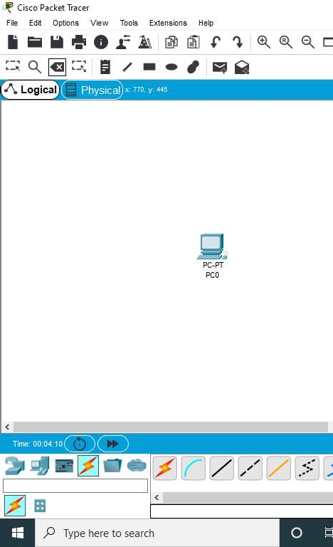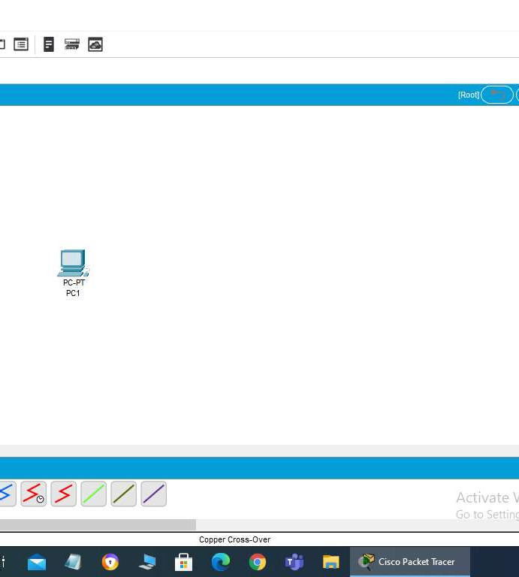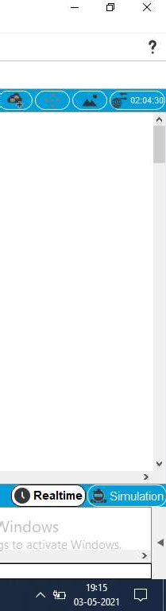

STEP 2

Connect both the pc with cross cable

